goju ryu karate-do
kuyu-kai
SOUTH AFRICA
member: WKF, NGKKI, AGKF & KSA


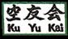
NPO Certificate No:
100-764-NPO
P.O. BOX 4311, WITBANK, 1035, Mpumalanga Province, South Africa:
T el: + 27 13 -696 2749, MOBILE: +27 72 330 8928; FAX NO.: +27 86 6939390
E-MAIL: shihanhumphrey@gmail.com /.info@kuyukaikarate.co.za
website: www.kuyukaikarate.co.za

E-MAIL: A PROVINCE

Re: FEEDBACK REPORT: NIHON GOJU RYU KARATE-DO KUYU-KAI

(NGKKI): SOUTH AFRICA: 5th ANNIVERSARY CELEBRATION:

13 – 22 OCTOBER 2012: INTERNATIONAL SEMINAR AND

CHAMPIONSHIP: WITBANK: MPUMALANGA PROVINCE:

SOUTH AFRICA

To: Media/Dojo Heads

The NGKKI- S.A held a very successful 5th Anniversary Celebration as from 13 – 22 October 2012 in the country after it was officially launched at Witbank, Mpumalanga Province, South Africa on the 20 October 2007 by the World Founder, Chief Instructor and President Grand Master Osamu Hirano – 8th Dan JKF, from Wakayama City, Japan.

The World Grand Master Hirano arrived in the country on the 13 October 2012 at OR Tambo International Airport, he was welcomed by the South African & African Branch Chief Instructor Shihan Humphrey Skosana and Shihan Cecil Mokoena from Soweto. The World Master started with the tour to SOWETO visiting all South African historic sites.

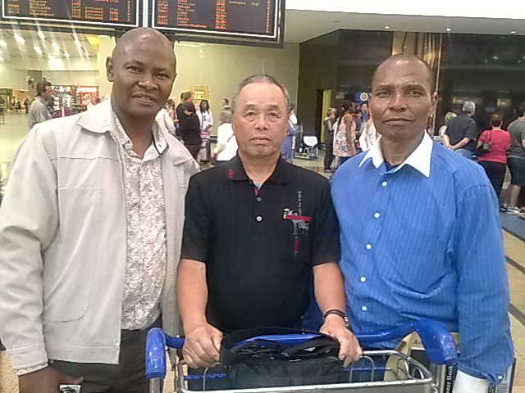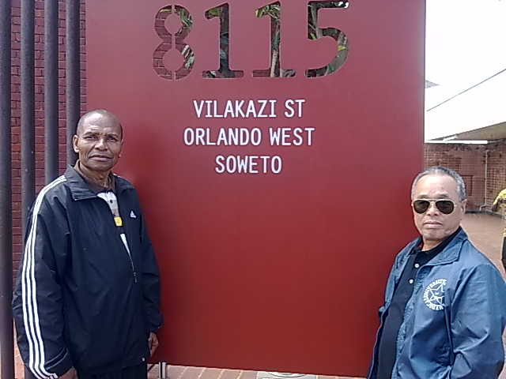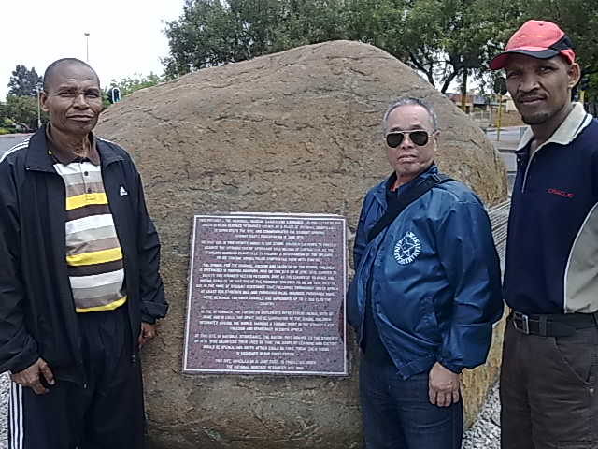
OR Tambo Int: Shihan Humphrey, At former President Mandela house Hector Pietersen Square
Saiko Shihan Hirano & Cecil Shihan

On the 15 October 2012, Training seminar was held at the Rustenburg we were welcomed with the warmed hands by the branch instructor Sensei Solly Van Der Walt and his team and later the evening we
were taken out for dinner at Sun City Superbowl Entertainment Centre.

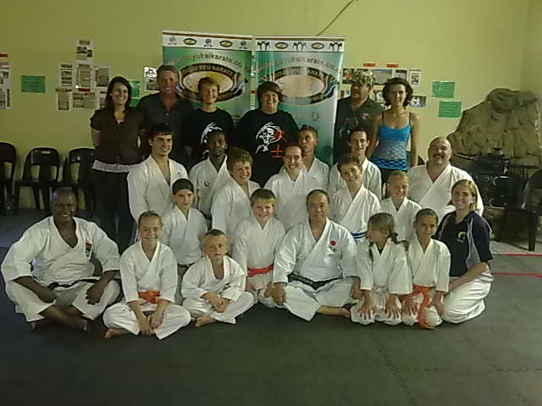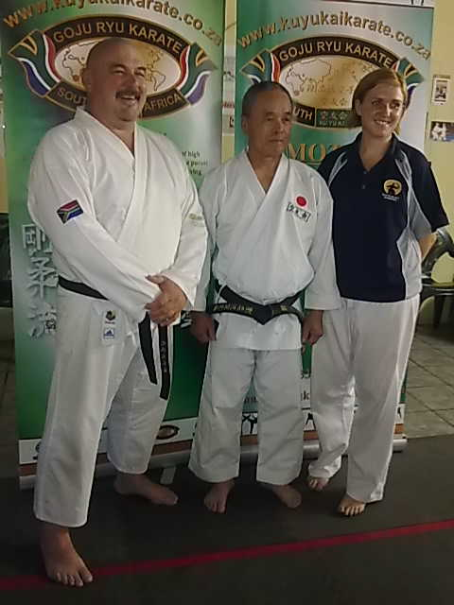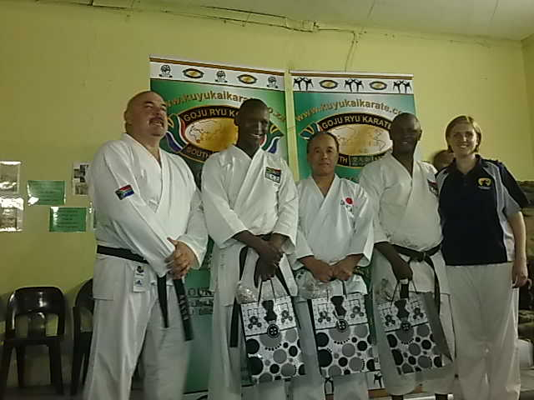

On the 16 October 2012, we left Rustenburg to Pretoria for sight-seeing at Hartebeespoort dam, market, Freedom Park, Union Building and end-up at Menlyn Mall for later lunch and left to eMalahleni (Witbank).
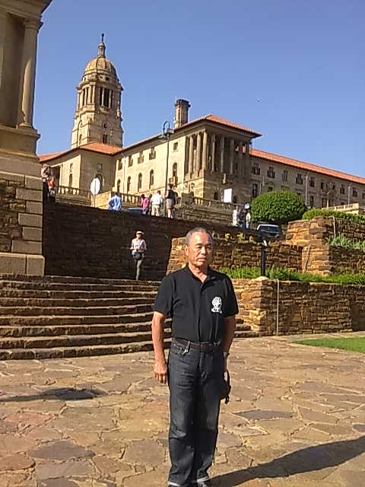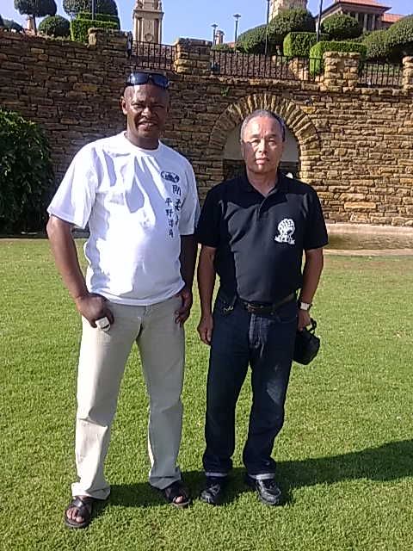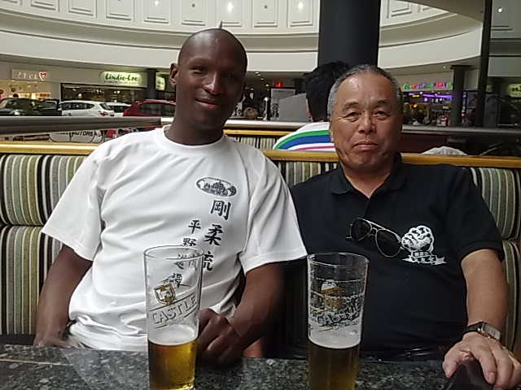

On the 17 October 2012, we had a day’s relaxing until 16:00 when we started with the Training Seminar at Witbank Correctional Centre Recreation Hall. On the 18 October 2012, we had rest day and on the 19 October 2012 we proceed with the Seminar and Black Belt Grading conducted by Saiko Shihan Hirano and congratulation for those who successfully passed the test:

- Shihan Humphrey Skosana – passed to 6th Dan Black Belt (Rokudan)
- Sensei Tshepo Tshakane – passed to 3rd Dan Black Belt (Sandan)
- Saneliso Skosana – passed to 1st Dan Black Belt (Jnr – Shodan)
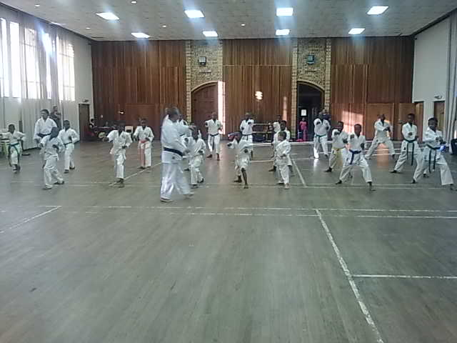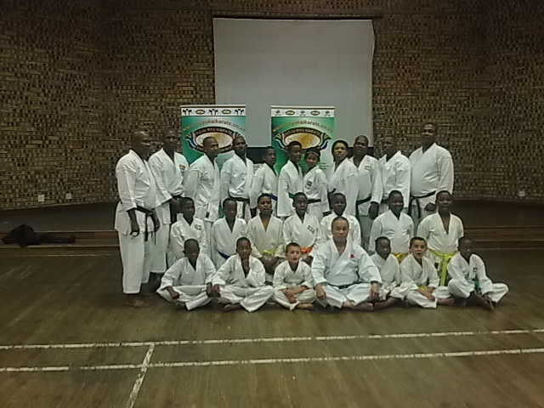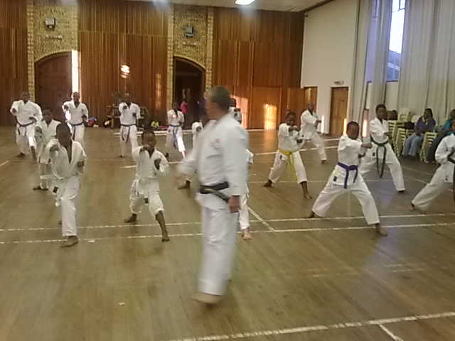

On the 20 October 2012, was the official 5th Anniversary Celebration championships which was graced with the attendance of the Executive Mayor of the City of eMalahleni (Witbank) Clr Salome Sithole was our VIP Guest, the make key note address, officially opened the championship and presented medals for the winners. The World NGKKI President Saiko Shihan Osamu Hirano officially presented Shihan Humphrey Skosana the 6th Dan Black Certificate whereby the Mayor Clr Salome Sithole and Shihan Cecil Mokoena who witnesses the presentation The following clubs participated are:
- Kuyukai Karate South Africa (NGKKI-SA)
- USKU – Johannesburg
- USKU – Bethal
- USKU – Secunda
- JKA – Secunda
- SSA – eMalahleni
- Danny’s Karate Club - Kriel
- Warrior Karate – Rustenburg
- Global Shotokan - Ermelo
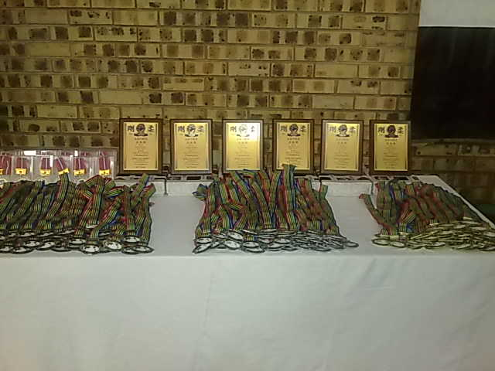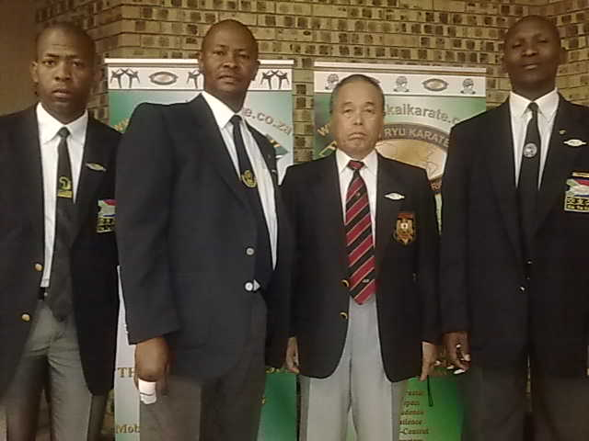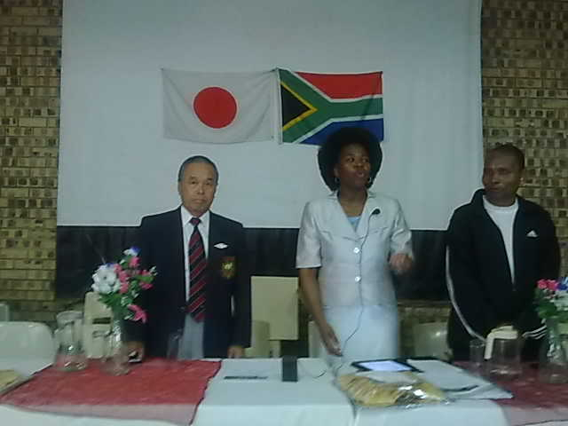
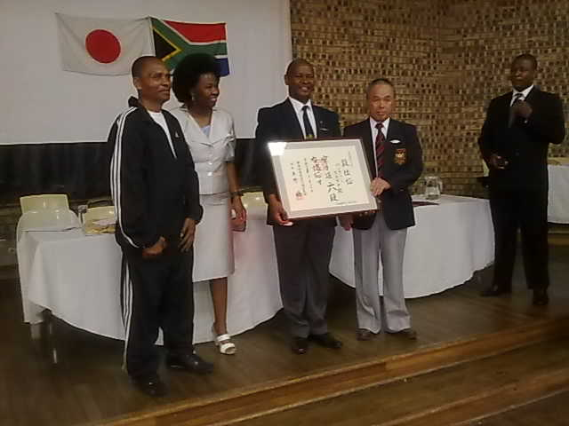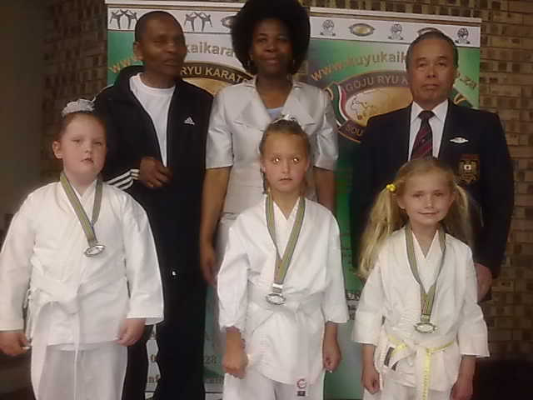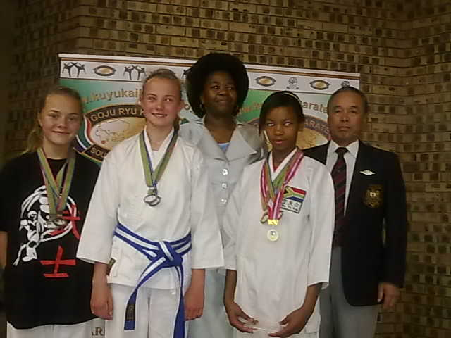
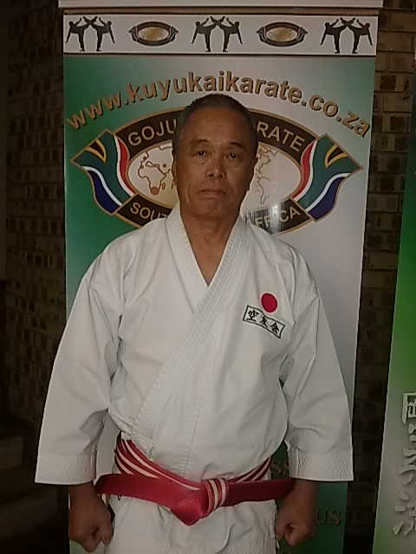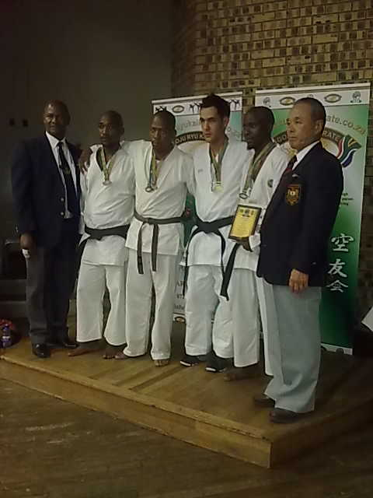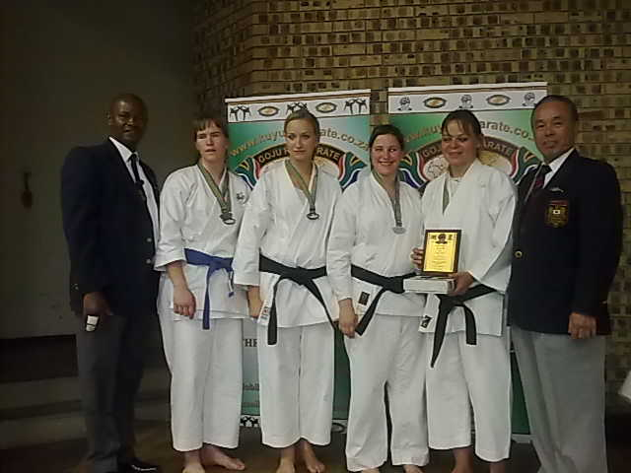

Thanks everyone who supported and ensures the events were successfully held.

Yours in Karate-do

_______________________
HUMPHREY SKOSANA SHIHAN
PRESIDENT/ CHIEF INSTRUCTOR
NGKKI- SOUTH AFRICA

